Posted 03/08/2016 at 1:48 pm by JAV
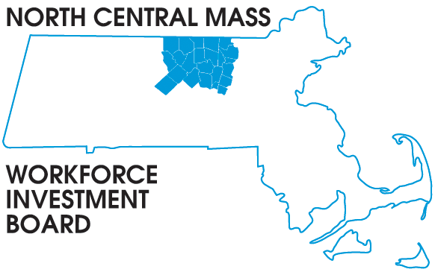
1355 Central Street Leominster, MA 01453 Phone: (978) 534 1023 Fax: (978) 534 1807

BOARD OF DIRECTORS MEETING

Tuesday, March 15, 2016

North Central Chamber of Commerce
860 South Street Fitchburg, MA
8:00 a.m. – 9:30 a.m.

AGENDA

Welcome & Introductions

Approve Minutes of the December 8, 2015 meeting (Vote required)

Approve the February 23, 2016 Executive Committee report
Finance: Barbara Mahoney
Executive: Tim (Vote required)

Strategic Planning Process and Progress to Date
Theresa Kane & Mike Noble

WIA to WIOA what does it really mean? Demand Driven video
Tim

Strategic Planning Board Activities
Theresa Kane

NEW Grant opportunities:
Tech Hire: Jackie Belrose
Youth Employment: Tim

Other Business

